



MODEL TASK FOR ASSIGNMENT 2 - SCANNER

RE – TD – TT for Platypus 2.0 – 5 marks in A2

Team: William Johns - Id: 040 832 509
/ [Student Name] - Id: [Student Id]

- Note: This task is part of the Assignment 2 from Compilers Course. Any problem contact your lab professor.

PART 1: RE – Regular Expression (1 mark)

Activity: Considering the following syntax:

- L = [A-Za-z] (Letters)
- Z = 0 (Zero digit)
- N = [1-9] (Non-zero digit)
- P = . (Point – for float numbers)
- S = $ (SVID terminator)
- Q = “ (String delimitator)
- E = EOFS (End of file symbol)
- O = [^LZNPSQE] (Other chars)

Describe in Platypus 2.0:

- AVID (arithmetic variable identifier)
- SVID (string variable identifier)
- IL (integer literal)
- FPL (integer literal)
- SL (string literal)

Answer:
AVID = L(L|N|Z)* //starts with a letter then anything after (max 8 characters)
SVID = AVID S //again starts with a letter then anything after finshing with a $ (max 8 characters including $)
IL = 0+|N(N|Z)* //can be a non zero amount of zeros, or a non-zero number followed by any amount of (N|Z)
FPL = IL P (N|Z)* //integer, point, then any amount of zeros or non zeros
SL = (L|Z|N|P|O)* //any amount (inc none) of enclosed by “” on both sides

PART 2: TD – Transition Diagram (2 marks)

Activity: Starting from the following diagram, create the complete TD for Platypus 2.0:

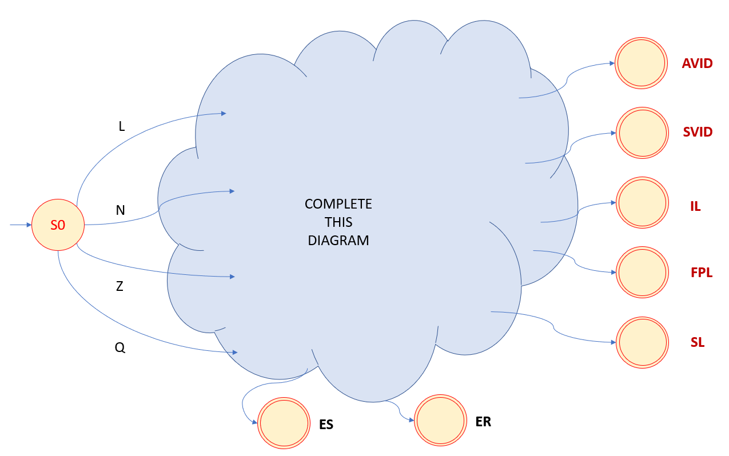

Where:
- AVID: Final state that recognizes arithmetic variable identifier.
- SVID: Final state that recognizes string variable identifier.
- IL: Final state that recognizes integer literals.
- FPL: Final state that recognizes float point literals.
- SL: Final state that recognizes string literals
- ES: Error state that does not retract.
- ER: Error state that retracts.

Suggestion: Use MS Video or PowerPoint to create the diagram (you can create an additional space to include the image / picture here).

Answer:

See attached document : Transition Diagram Assignment 2.pptx

PART 3: TT – Transition Table (2 marks)

Activity: Complete the following table that defines the DFA for Platypus 2,0:

Current | Input Symbol |  |  |  |  |  |  |  | State
State | L | Z | N | P . | S $ | Q “ | E | O | Type
0 | 1 | 6 | 4 | ES | ES | 9 | ES | ES | NOAS
1 | 1 | 1 | 1 | 2 | 3 | 2 | 2 | 2 | NOAS
2 | IS | IS | IS | IS | IS | IS | IS | IS | AVID
3 | IS | IS | IS | IS | IS | IS | IS | IS | SVID
4 | ES | 4 | 4 | 7 | 5 | ES | 5 | 5 | NOAS
5 | IS | IS | IS | IS | IS | IS | IS | IS | IL
6 | ES | 6 | ES | 7 | 5 | ES | 5 | 5 | NOAS
7 | 8 | 7 | 7 | 8 | 8 | 8 | 8 | 8 | NOAS
8 | IS | IS | IS | IS | IS | IS | IS | IS | FPL
9 | 9 | 9 | 9 | 9 | 9 | 10 | ES | 9 | NOAS
10 | IS | IS | IS | IS | IS | IS | IS | IS | SL
11 | IS | IS | IS | IS | IS | IS | IS | IS | ES
12 | IS | IS | IS | IS | IS | IS | IS | IS | ER

Use the following representation to this table:
- For input symbols:
  - Numbers = For indicate states
- For state type:
  - AVID (arithmetic variable identifier)
  - SVID (string variable identifier)
  - IL (integer literal)
  - FPL (integer literal)
  - SL (string literal)
  - ES = Error state (no retract)
  - ER = Error state with retract
  - NOAS = Non-acceptable state

Update: 25th Sep 2020.

Adapted from resources developed by Prof. Svillen Ranev (Algonquin College, 2019)

